**Programming Part**

Analysis 1

We first keep the U, V unchanged and change the Y from 2 to 4, the result is showed below (the left is the original image, the right one is subsampled image):

We first keep U and V 1 and 1 respectively and vary Y.

Y U V: 2 1 1

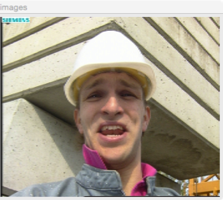

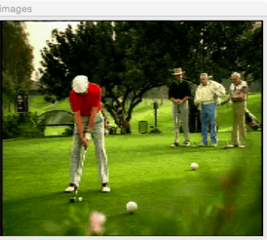

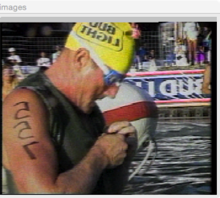

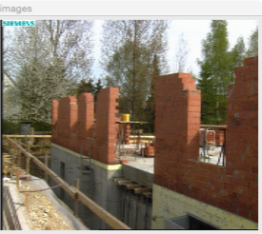

YUV: 4 1 1

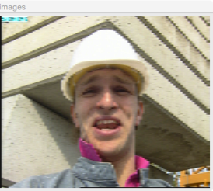

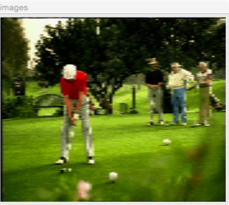

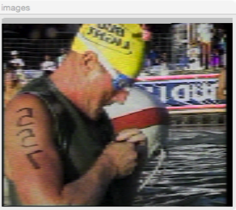

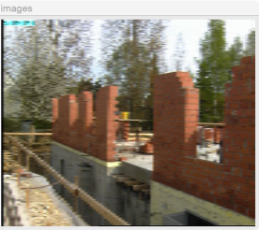

YUV: 8 1 1

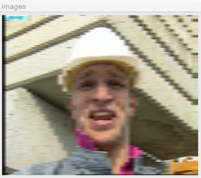

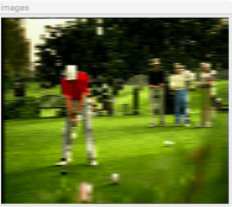

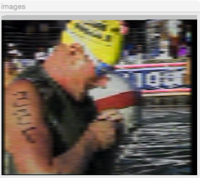

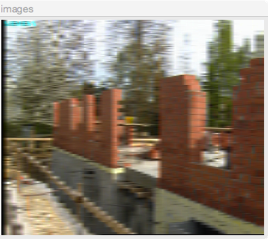

And then we keep Y and U 1 and 1, and vary V

YUV: 1 1 4

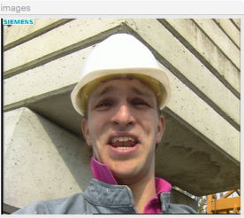

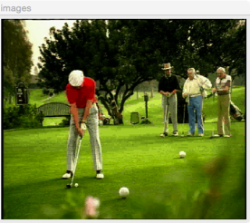

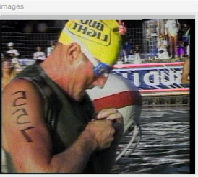

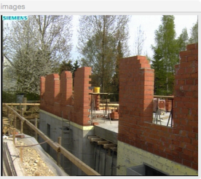

Y U V: 1 1 16

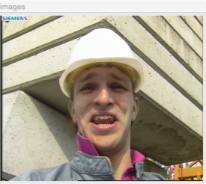

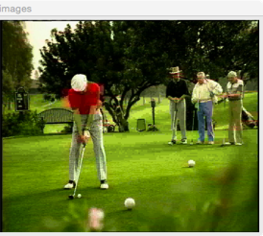

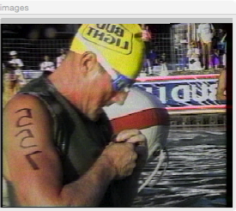

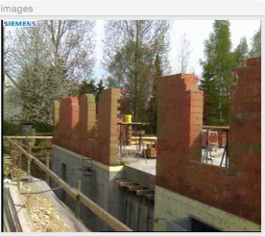

Y U V: 1 1 24

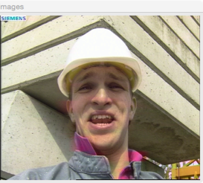

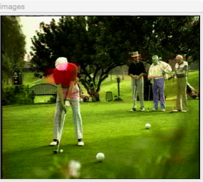

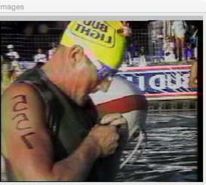

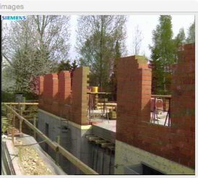

In the end, we keep Y V at 1 and 1, and vary U:

Y U V: 1 4 1

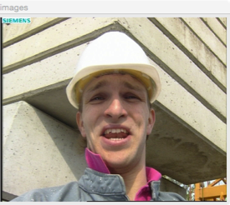

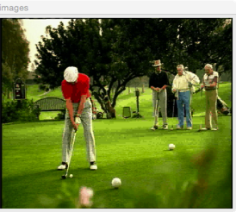

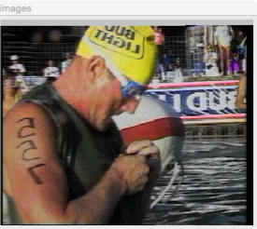

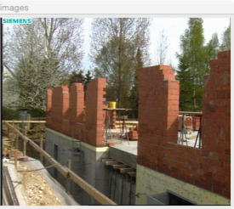

Y U V: 1 16 1

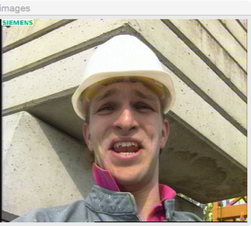

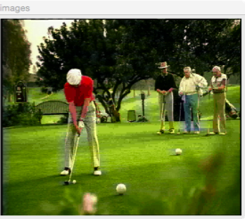

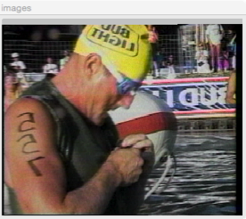

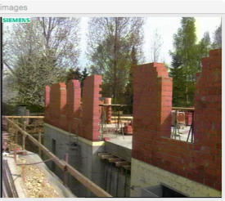

Y U V: 1 24 1

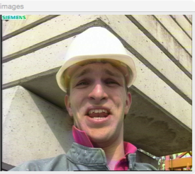

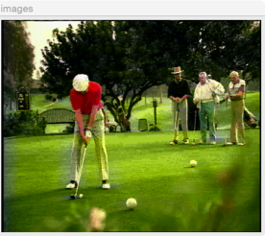

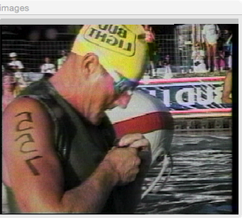

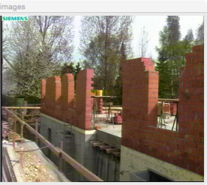

Y U V: 1 48 1

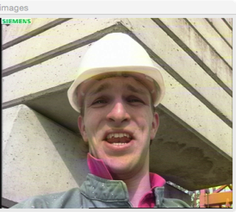

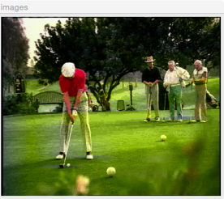

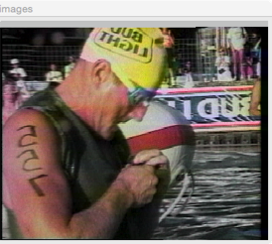

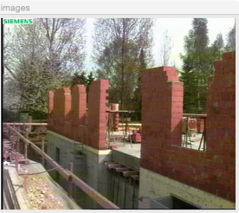

Summary

(My feeling to the images. 3 present feeling good, 2 for so so, 1 for bad)

|  |  |  |  |  |
| --- | --- | --- | --- | --- |
| YUV Subsample | Image1 | Image2 | Image3 | Image4 |
| 2 1 1 | 3 | 2 | 3 | 3 |
| 4 1 1 | 1 | 1 | 1 | 2 |
| 8 1 1 | 1 | 1 | 1 | 1 |
| 1 1 4 | 3 | 3 | 3 | 3 |
| 1 1 16 | 3 | 1 | 3 | 2 |
| 1 1 24 | 2 | 1 | 2 | 2 |
| 1 4 1 | 3 | 3 | 3 | 3 |
| 1 16 1 | 3 | 2 | 3 | 3 |
| 1 24 1 | 3 | 2 | 3 | 2 |
| 1 48 1 | 2 | 2 | 2 | 2 |

Analysis: From the result images, we can see that even though we subsample the Y channel with a very small value 4, I feel that the image get blurred after subsampling. However, for the U and V channels, when we subsample them with value 16, which is 4 times larger than the Y channel, I still feel it is the same image after subsampling. Only when the value goes up to 24, I will feel the some of the colors in the image change. Moreover, the subsampling for UV affects each image independently. We can see that in image 4, most of the pixels are red and green. So the loss of UV channel data will affect the feeling to the image. And I give it lower rate compare to most of the other images with the same subsampling parameters. Besides for image2, most of the pixels are green and our focus is on the people in red. So, the loss of UV channel data will also affect my feeling greatly, so lower rate is given compared to other images. For images 1 and 3, since they are mainly white and black, which does mostly the Y channel affect, so the loss of UV channel doesn’t have a great impact to the feeling of the image.

So my conclusion is that the Y channel has a larger effect on the image than the UV channels, we need to keep as much as Y channel data possible to make the subsampled image looks as the same as the original one. And UV channels have different impacts on different images with different main colors.

Question 2

Let’s use the YUV 4:1:1 image for the discussion(show below).

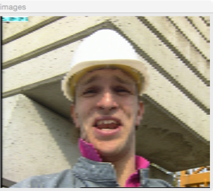

We can see that there are many small triangles after subsampling in the image. This is caused by the loss of Y channel data. To reduce the effect of aliasing, we need to reduce the frequency of the original image before subsampling it. One way to do that is to use an average filter and do a preprocess before subsampling. Here, for the YUV 4:1:1, there are 3 average filters with size 3*3, 5*5, 7*7, the result is shown below respectively:

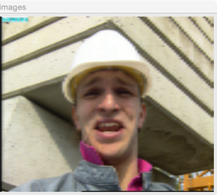

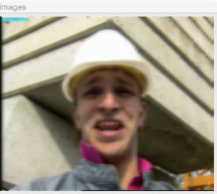

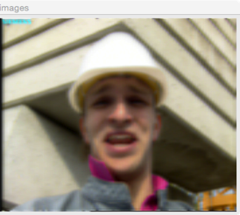

(the first one is 3*3, the second is 5*5, the last one is 7*7).

So we can see that the last two images we can the aliasing is disappeared, but the image get blurred.

The process can be done before we subsample the image. Typically, we can do it in the RGB color space before transferring into YUV space. But we can also only filter the Y channel after the transferring to get the same result. (I don’t filter the UV channels, since they record the color info, and we will get weird result if we filter them) I prefer do it in the YUV color space, since the color looks more close to the original image. (see below)

Filtering in RGB color space (5*5 average filter):

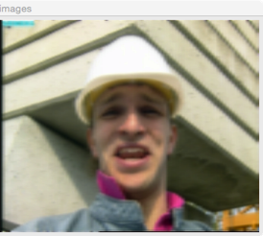

Filtering in YUV color space (5*5 average filter):

